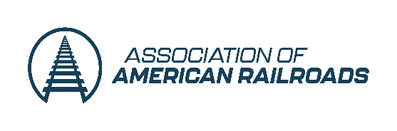

EXHIBITOR REGISTRATION FORM
AAR HAZARDOUS MATERIALS & TANK CAR COMMITTEE MEETINGS

EVENT ADDRESS: The Westin Galleria Dallas, 13340 Dallas Parkway, Dallas, TX 75240
EVENT DATES: October 20-22, 2026
COST: $1,500 per company for Tabletop Space to exhibit at Hazardous Materials and Tank Car Committee Meetings, October 20-22, 2026. All exhibitors/exhibits will be in the Dallas Foyer outside of the meeting rooms. Complete the form below and send it to skilfeather@aar.org

Name

Company/Organization
Address
City
State
Zip Code
Phone
Email

Submit form to Stephanie Kilfeather at skilfeather@aar.org The AAR will send an invoice for payment, or call Stephanie at (202) 639-2164 and make a credit card payment.

