Chair: Roger Dalske, Members: Joe Caccamo, Scott Murray

Proposal:

1.6.4.4 Documents to be supplied to individuals making repairs:

1.6.4.4.1

The tank car owner must supply to the person or facility responding to a tank car service event, making temporary repairs that cause alteration, conversion, repair, or qualification of the owner's equipment, the documents applicable to the repair, in a timely manner. All work not directly required to restore the car to a condition to be safely moved or held for owner’s repair management must be approved by the owner in advance.

1.6.4.4.1.1

This information could be in the form of any one of the following: Drawing, COC, TCID entry, R1, procedures, manuals, records and/or written instruction. The owner is not required to supply proprietary information, only information applicable to make repairs. The requestor should be aware that the seller (manufacturer/private car owner) is only required to supply and therefore the owner may only have the documents listed in table 1.20

1.6.4.4.3

The person or facility must not use, copy, distribute, forward or provide to another person the owner's confidential and proprietary written instructions, procedures, manuals, and records without the owner's permission.

1.6.4.4.4

The person or facility making changes to the tank car must report all work performed to the owner and/or maintenance party; and shipper/consignee in a timely manner.

1.6.4.4.5

The requestor for information to effect repair must provide the following information to the owner and/or maintenance party listed in UMLER (request format is primarily for adhoc repair events) :

Current Car Mark and Number

Built Date (preferred to validate owners response)

DOT/TC Stencil Specification

Commodity, UN/NA number (SDS is the preferred format)

Brief description of issue being addressed (i.e., leaking liquid valve at B end):

Back ground info:

UMLER (Siebold):

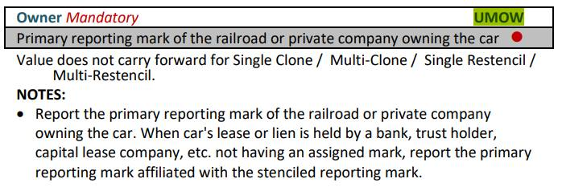

Lessee

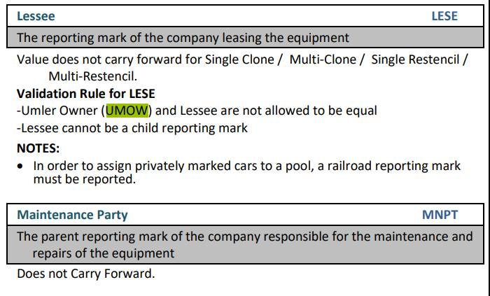

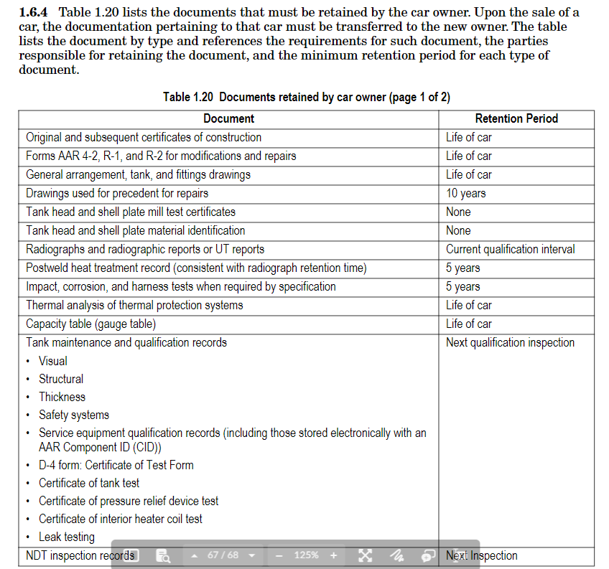

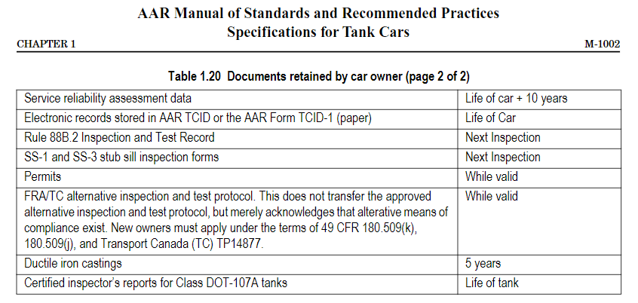

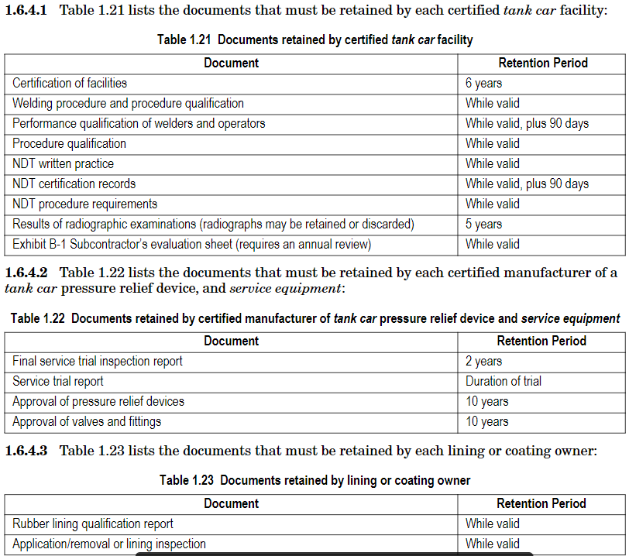

180.513 Repairs, alterations, conversions, and modifications. (a) To work on tank cars, a tank car facility must comply with the applicable requirements of this subpart, the AAR Specifications for Tank Cars (IBR, see § 171.7 of this subchapter), and the owner's requirements.  (b) Responsibilities of Tank Car Facility. A tank car facility must obtain the permission of the equipment owner before performing work affecting alteration, conversion, repair, or qualification of the owner's equipment. For the purposes of qualification and maintenance, the tank car facility must use the written instructions furnished by the owner or have written confirmation from the owner allowing the use of written instructions furnished by the owner or have written confirmation from the owner allowing the use of written instructions furnished by another. A tank car facility must not use, copy distribute, forward or provide to another person the owner's confidential and proprietary written instructions, procedures, manuals, and records without the owner's permission. A tank car facility must report all work performed to the owner. The tank car facility must also report observed damage, deterioration, failed components, or non-compliant parts to the owner. A tank car facility must incorporate the owner's Quality Assurance Program into their own Quality Assurance Program