Charge:
To list the paragraphs in Appendix D of M-1002 that are the same requirements in 49 CFR Part 180 Subpart F as published in U.S. DOT final rulemaking HM-216B released 6/25/2012.
Time Table: (submit to TCC by end of Q2 2021 or latest, August 2021)

Meeting Agenda
Anti-trust statement
Attendance
Role call and updated team intro
Old Business
- Reviewed items discussed with Ken Dorsey for guidance (included in last meeting minutes)

New Business
- Tracker Review Reviewed items on the Tracker (attached) for assignment.
  - Items for Stub Sill, Heater Coil, and Rule 88 have been added.
  - Members are asked to review and contact members listed to participate or me to request any that remain blank – will review during our next meeting on 4/28 (after meeting with B. Sielbold on T5.32 – Item 4 below).
- Discussed concerns about inspection types to be reviewed in an ad hoc meeting on 4/14 (see item 3 below).
- Discussed the impact of potential changes in ownership definitions by PHMSA (as a specific item addressed in HM-216B as well as PHMSA interpretation to Wells Fargo from 2019). Will need to avoid issues with potential change (See items 1 & 2 below)

Homework Items:
- L. Loman to provide 2019 PHMSA interpretations on lining/car owner requirements.
- D. Welch to provide proposed new PHMSA definitions of Coating/Service Equipment/Tank car Owners.
- D. Welch to issue a Doodle poll to meet on the afternoon of April 14th to review impact on definitions from Appendices T & W.
- D. Welch to request a meeting with B. Siebold to review interaction with T5.32 (including J. Schultz and L. Loman).

Addendum
Homework Item 1 – sent by L. Loman on 4/7 and attached to these minutes
Homework Item 2 – shown below, full document attached to these minutes
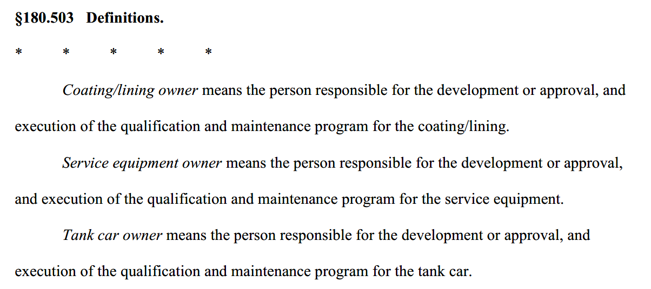
Homework Item 3 – Poll has been issued
Homework Item 4 – Request was sent to B. Siebold on 4/7

